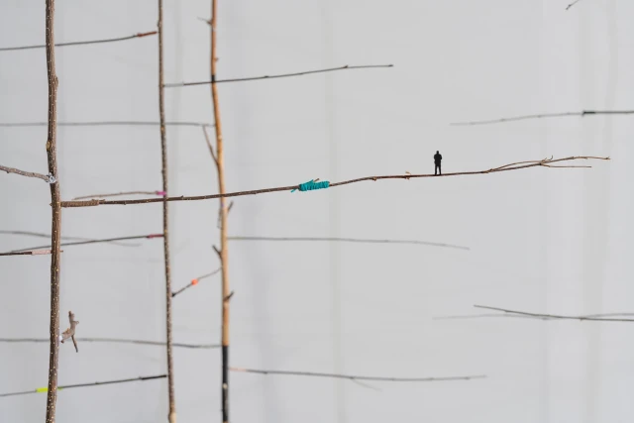
Class Level & Name: 1st year Aideen______________________  Time and Duration of Lesson: _________80 min_________ |  | Date: _9.3.2020_________________________________ Discipline: ___Art strand_______________________________
Content
Learning Outcomes/ Learning Intentions/ Success Criteria | Students will be able to:  Learning Outcomes:  2.2 interrogate and communicate ideas about different crafts using critical and visual language  2.8 interpret the narrative, symbols and functions used in craft from their own and other world cultures  2.15 justify the choice of media in their own or others’ craft work  Learning Intentions:  To look at the effects of migration for those forced to leave their home country.  To examine some of the causes.  To look at artist that have explored this topic.  To create an art work that emphasizes with a migrant.  To discover examples of migration in everyday life  To celebrate cultural diversity and multicultural living as a result of people’s movements and interactions  Success Criteria:  I will look at the effects of migration for those forced to leave their home country.  I will examine some of the causes.  I will look at artist that have explored this topic.  I will create an art work that emphasizes with a migrant.  I will discover examples of migration in everyday life  I will celebrate cultural diversity and multicultural living as a result of people’s movements and interactions
Resources  Health & Safety | Resources: paper, pencils, charcoal, pastels,  Health & Safety: To ensure:
Literacy / Numeracy | In reading and decoding the map of trees migrating.
Differentiation | There is one girl who said her parents won’t let her take part and so I will sit her at the back off the class and set her an extended task of last wees lesson. Providing her a with a mirror to do a self portrait. I will also provide her with my audible to listen to music so that (should the parents have something against the content) she will be well and truly in her own little world at the back.
Method
Introduction | We start the lesson off with the ball of wool activity where students say the country they would like to go to and why throwing it to someone else in the class. Having learned out of experience at the end of creating the web I will get students to throw the ball back to the person they received it from and we wind the ball back up together that way.  We then look at Migration asking the students:  * What they know about migration already.  *Why they imagine people might leave (or be forced to leave) a country?  * What challenges do you think you would face if you migrated?  If we get dead silence for the first question we put up a slide where we ask students to match the terms refugee, migrant and asylum seeker with the definitions.  Erin then talks to them about migration to and from Ireland and talks to them about some of the benefits of migration, what migration has brought us ( food, clothing...).  Students are asked to write down three favorite dishes  On the board we then discuss students answers do they think these dishes are from Ireland or not? Do they know where these dishes are from.  We look at other examples of migration in every day life and the riches migration has brought us.  And uses a map of Syria as a visual aid to find out what students already know about the situation in this country and builds up on their prior knowledge.
Development | We start another activity entitled ‘Should I stay or should I go’ whereby students are split into four groups and are each given a family. Students either stand up or sit down depending on whether they decide to stay or go.  I ask them: How did this exercise make you feel?  Do you think you would like to be in this position?  We examine how artists such as Anita Groener and AI Wai wai have explored the subject of migration.  Showing the students images of this work I ask them how they think this ties in with what we just talked about?  Why they think the artists Anita Groener used branches and trees?  Why did she presented them in this way.  Why do they think the artist Ai WeiWei used live jackets?  Why did he place them in public places within city ponds?  Each student receives a little cardboard suitcase and the description to a person and are asked to think about what they would put into their suitcase if they were that child and about to leave their home country for ever.
Summary, Revision, Recapitulation and Conclusion | Students write into the silhouette of a person:  3 things I learned  2 things I found interesting  1 Question I still have
Primary & Secondary Visual Aids | Powerpoint images of Anita Groeners work,  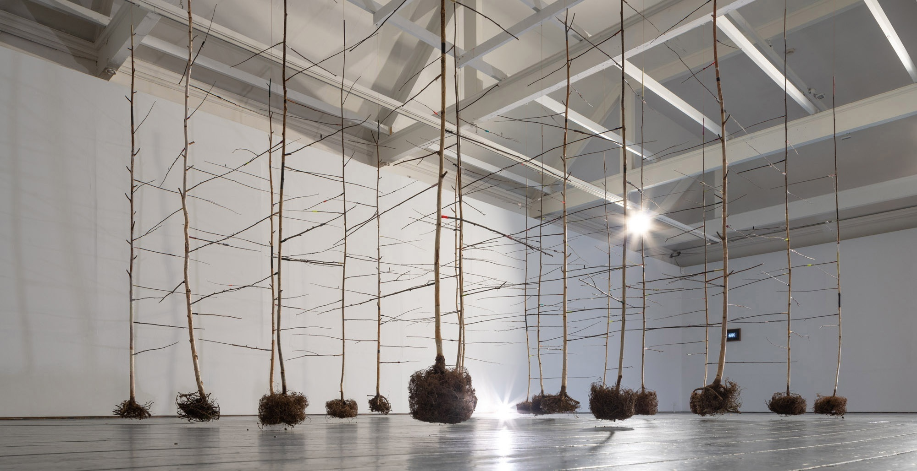  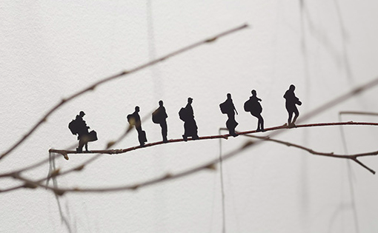  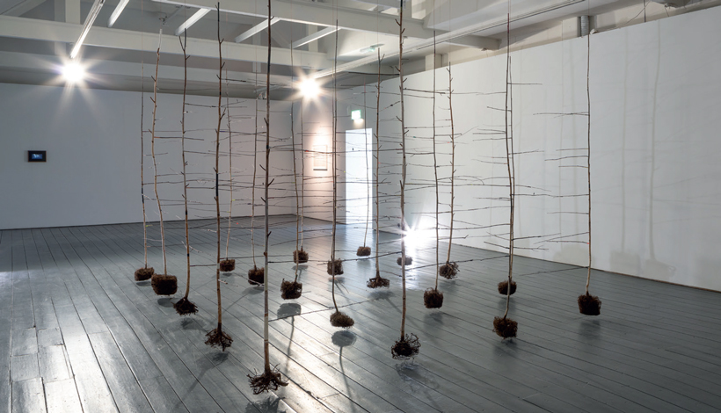  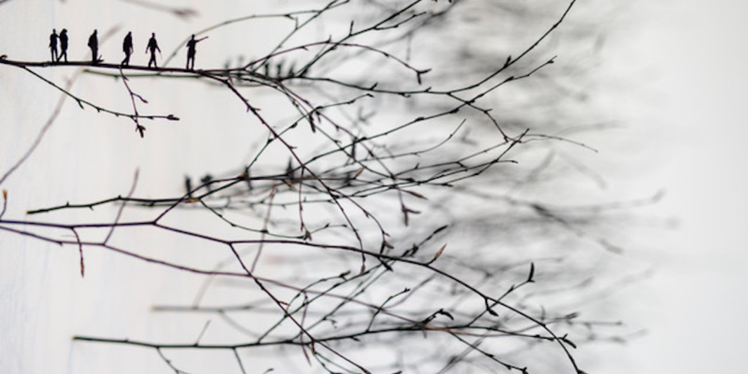  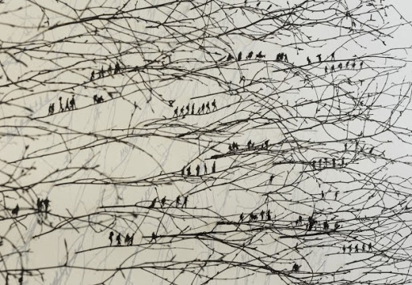
Examples of pupil’s responses (Visual)
Post-Lesson Reflection | The game with the wool was interesting, a lot of the students said they would travel to New York and visit relatives, but we also to the Caribbean, Tokyo...  As I suspected the students knew a lot of the terms, migrant, asylum seeker and refugee already. Migrant and refugee they were able to give a definition for, whereas they had only heard the term asylum seeker but could not define it.  The game with the families also went down well with the students, although I think if I were to do it again, I would have the students close their eyes and raise their hand if they would leave, as the different families all chose to stand up at the same time as the other families did.  The artist’s work was a bit difficult to use as I had seen both works installed and was so tempted to tell them everything rather than ask them questions about the work and let them reach conclusions about these pieces themselves. Doing so however was so worth it. As student recognized things like the trapped state of the grid like structure in Anita Groener’s work and the relation to refugees themselves and were able to recognize the trees as symbols for the refugees…  For creating the inside of the suitcases students created the most thoughtful installations, really thinking about their person. One student placed a family foto on the inside of the suitcase, a blanket and wedding ring inside the box. Another girl who had received the story of a young refugee with a cat, had chosen to place mainly objects for the cat inside her suitcase. As I allowed the students to also think of things that they would put in the suitcase if they weren’t too large or non tangible; one girl placed an entire house in the suitcase, another made a mini person, her friend that she would want to take with her. Two girls thought long and hard about a person one of the two had received, reading and rereading the description for that person and then deciding to make them a green card as they were on a journey to America. Another girl who had received a teacher decided to spell the name of her person in wooden beaded letters, and create soft lining within the suitcase.  All in all I think the students created very thoughtful pieces. I think the students could have done with a bit more time for the suitcases, but as one girl in the class can not participate and I have a lot of other things to continue with them, we will have to leave it at this one lesson. Certainly I think I would spend a lot more time on something like this when I do it again, and I will, most certainly.

